Sprint 3 Status Report
For the Girl Scouts of America Badge Tracking
Application

By
Matt Eck
Michael Glosecki
Nathan Martz
Ryan Schroeder

Of
Team Cookie Council

1. The Council estimated 70 hours to complete sprint 3 however the sprint took us 60.5 hours. After the sprint was completed we had 0 hours left on the story tasks selected.

2. All stories on product backlog were selected for Sprint three. The goal of sprint three was to create a good structure of the database and to get a rough HTML page up.
- Revisions to database made by Matt & Ryan
- Insert statements generated by Matt & Ryan
- Database mildly tested by Matt & Ryan
- Meeting with Socratis Tornaritis Attending: Mike, Nate, Ryan
- Refinement of HTML pages by Nate & Mike

3. Client was updated regularly about the application status, and the need for a server was reiterated but with no response.

4. The only risks we attempted to mitigate was the risk of not having a server to implement the system on. We did so by reminding the client of our need of a server and upon no response from client we began developing locally using Xampp.

Project Burndown chart
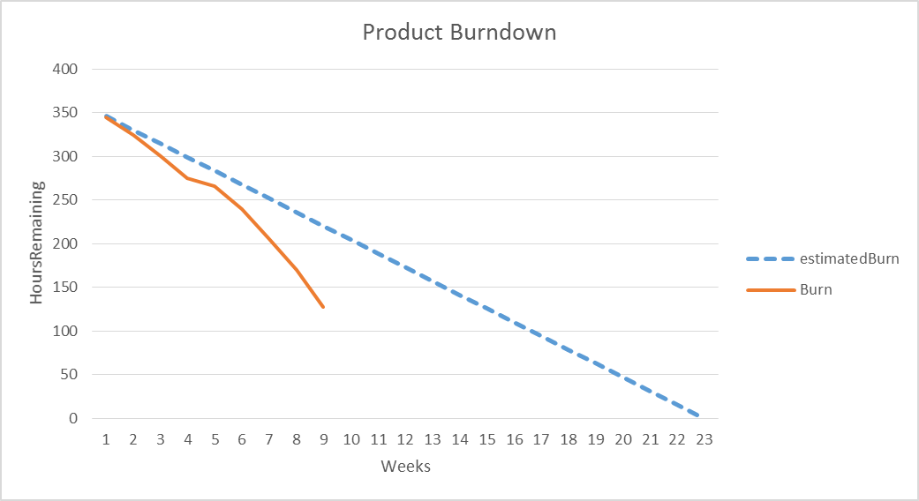

Sprint Burndown Chart
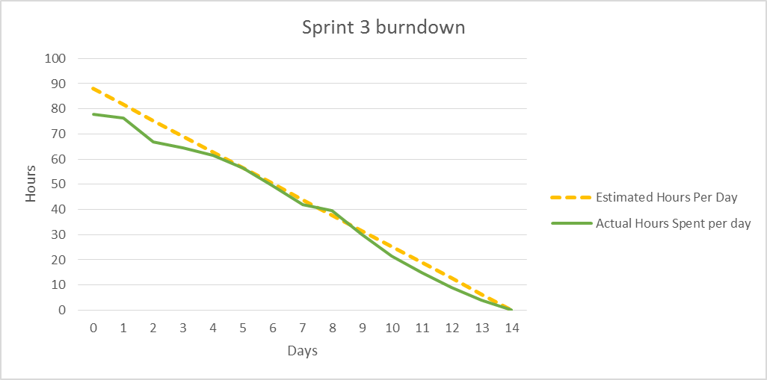

Weekly Development Effort
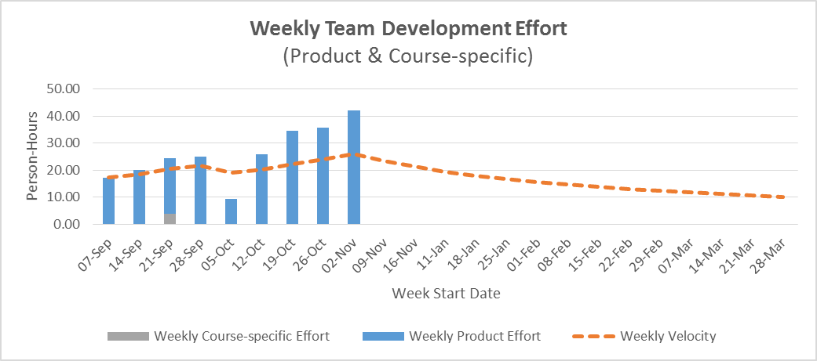

Daily Team Effort
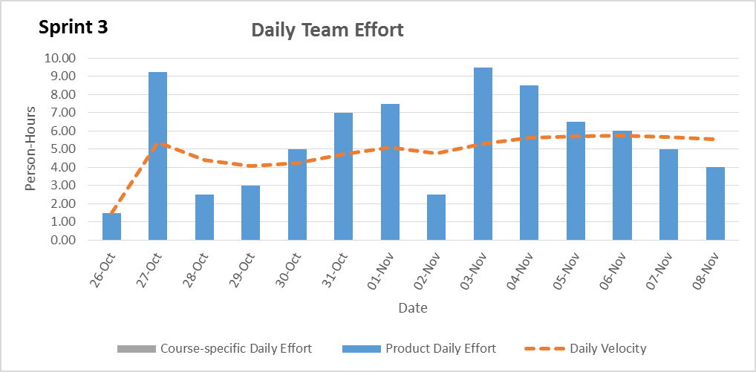

Team Member Effort
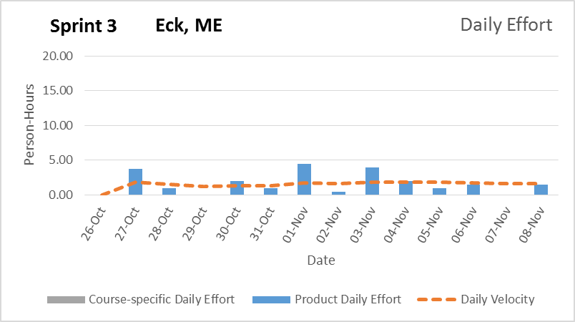

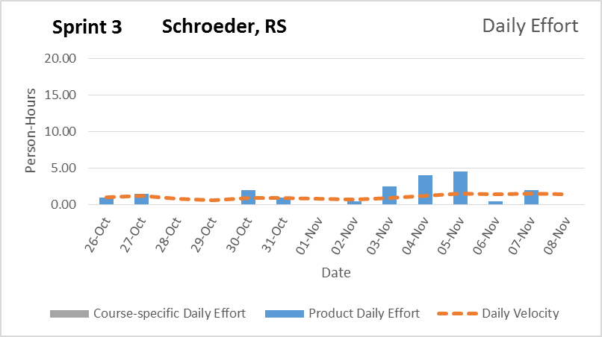

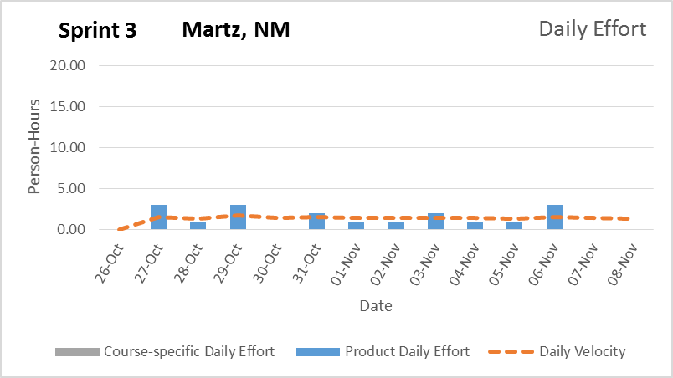

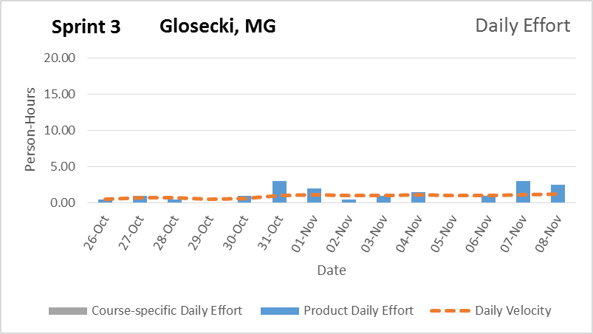

6. The team is confident that the product will be delivered to the client within the time frame with all functionality implemented. Our product Burn down shows that our progress is a bit behind but we feel that this is due to poor estimations of tasks.


Signature Date

__________________________________________ ______________

__________________________________________ ______________

__________________________________________ ______________

__________________________________________ ______________

